**Constructor:**

1. Object creation is not enough, compulsory we should perform initialization then only the object is in a position to provide the response properly.

2. Whenever we are creating an object some piece of the code will be executed automatically to perform initialization of an object this piece of the code is nothing but constructor.

3. Hence the main objective of constructor is to perform initialization of an object.

**Example:**

**class Student**

**{**

**String name;**

**int rollno;**

**Student(String name,int rollno) //Constructor**

**{**

**this.name=name;**

**this.rollno=rollno;**

**}**

**public static void main(String[] args)**

**{**

**Student s1=new Student("vijayabhaskar",101);**

**Student s2=new Student("bhaskar",102);**

**}**

**}**

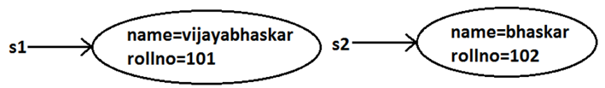

**Constructor vs Instance Block:**

1. Both instance block and constructor will be executed automatically for every object creation but instance block 1st followed by constructor.

2. The main objective of constructor is to perform initialization of an object.

3. Other than initialization if we want to perform any activity for every object creation we have to define that activity inside instance block.

4. Both concepts having different purposes hence replacing one concept with another concept is not possible.

5. Constructor can take arguments but instance block can't take any arguments hence we can't replace constructor concept with instance block.

6. Similarly we can't replace instance block purpose with constructor.

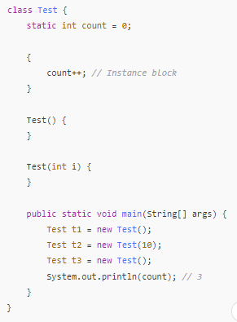

**Rules to write constructors:**

1. Name of the constructor and name of the class must be same.

2. Return type concept is not applicable for constructor even void also by mistake if we are declaring the return type for the constructor we won't get any compile time error and runtime error compiler simply treats it as a method.

**Default constructor:**

1. For every class in java including abstract classes also constructor concept is applicable.

2. If we are not writing at least one constructor then compiler will generate default constructor.

3. If we are writing at least one constructor then compiler won't generate any default constructor. Hence every class contains either compiler generated constructor (or) programmer written constructor but not both simultaneously.

| **Programmers Code** | **Compiler Generated Code** |
| --- | --- |
| class Test { } | class Test {  Test() {  super();  }  } |
| public class Test { } | public class Test {  public Test() {  super();  }  } |
| class Test  void Test() { } | class Test {  Test() {  super();  }  void Test() { }  } |
| class Test {  Test(int i) { }  } | class Test {  Test(int i) {  super();  }  } |
| class Test {  Test() { }  } | class Test {  Test() {  super();  } |
| class Test {  Test(int i) {  this();  }  Test() { }  } | class Test {  Test(int i) {  this();  }  Test() {  super();  } |

**Super() vs this():**

The 1st line inside every constructor should be either super() or this() if we are not writing anything compiler will always generate super().

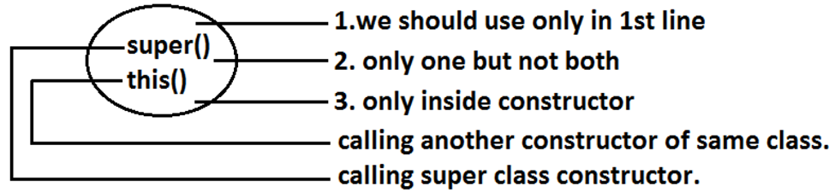

**Overloaded Constructers:**

A class can contain more than one constructor and all these constructors having the same name but different arguments and hence these constructors are considered as overloaded constructors.

**class Test {**

**Test(double d){**

**System.out.println("double-argument constructor");**

**}**

**Test(int i) {**

**this(10.5);**

**System.out.println("int-argument constructor");**

**}**

**Test() {**

**this(10);**

**System.out.println("no-argument constructor");**

**}**

**public static void main(String[] args) {**

**Test t1=new Test(); //no-argument constructor/int-argument**

**//constructor/double-argument constructor**

**Test t2=new Test(10);**

**//int-argument constructor/double-argument constructor**

**Test t3=new Test(10.5);//double-argument constructor**

**}**

**}**

**Note:** Compiler is responsible for the following checkings.

1. Compiler will check whether the programmer wrote any constructor or not. If he didn't write at least one constructor then compiler will generate default constructor.

2. If the programmer wrote any constructor then compiler will check whether he wrote super() or this() in the 1st line or not. If his not writing any of these compiler will always write (generate) super().

**Static Block:**

· Static blocks will be executed at the time of class loading hence if we want to perform any activity at the time of class loading, we have to define that activity inside static block.

· Within a class we can take any no. Of static blocks and all these static blocks will be executed from top to bottom.

**Example:**

The native libraries should be loaded at the time of class loading hence we have to define that activity inside static block.

**class Test**

**{**

**static**

**{**

**System.loadLibrary("native library path");**

**}**

**}**